1. Uzupełnij schemat – wpisz wzory sumaryczne i strukturalne podanych związków chemicznych.

________________________________________

________________________________________

imię i nazwisko

__________________ _________________

klasa data

Glicerol – alkohol polihydroksylowy

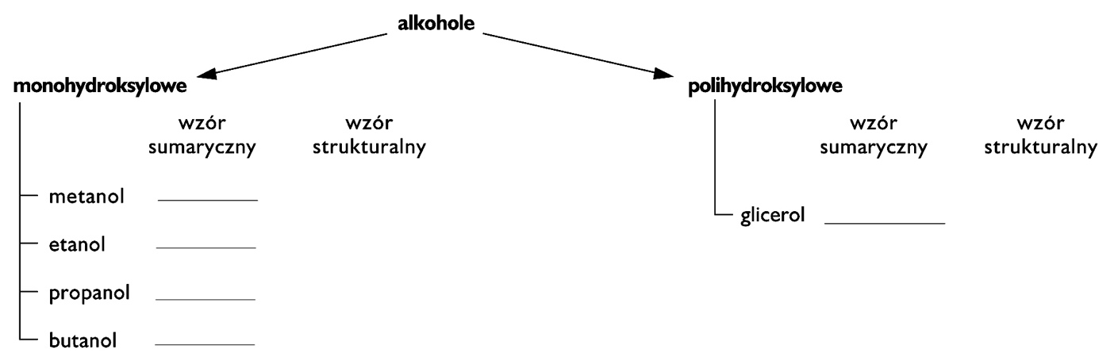

1. Uzupełnij tabelę. Wpisz właściwości glicerolu.

|  |  |
| --- | --- |
| **Stan skupienia** |  |
| **Barwa** |  |
| **Zapach** |  |
| **Rozpuszczalność w wodzie** |  |
| **Reaktywność chemiczna –**  **ulega reakcji** | • spalania ____________________________________,  zgodnie z równaniem:  _____________________________________________ |
| **Nazwa systematyczna** |  |

1. Uczeń wymieszał 100 cm3 glicerolu o gęstości 1,258 $\frac{g}{{cm}^{3}}$ z taką samą ilością wody. Następnie dolał jeszcze raz 100 g H2O. Oblicz stężenie roztworu, który otrzymał. Zaproponuj sposób rozdzielenia tak przygotowanej mieszaniny.

|  |  |  |  |  |  |  |  |  |  |  |  |  |  |  |  |  |  |  |  |  |  |  |  |  |  |  |  |  |  |  |  |
| --- | --- | --- | --- | --- | --- | --- | --- | --- | --- | --- | --- | --- | --- | --- | --- | --- | --- | --- | --- | --- | --- | --- | --- | --- | --- | --- | --- | --- | --- | --- | --- |
|  |  |  |  |  |  |  |  |  |  |  |  |  |  |  |  |  |  |  |  |  |  |  |  |  |  |  |  |  |  |  |  |
|  |  |  |  |  |  |  |  |  |  |  |  |  |  |  |  |  |  |  |  |  |  |  |  |  |  |  |  |  |  |  |  |
|  |  |  |  |  |  |  |  |  |  |  |  |  |  |  |  |  |  |  |  |  |  |  |  |  |  |  |  |  |  |  |  |
|  |  |  |  |  |  |  |  |  |  |  |  |  |  |  |  |  |  |  |  |  |  |  |  |  |  |  |  |  |  |  |  |
|  |  |  |  |  |  |  |  |  |  |  |  |  |  |  |  |  |  |  |  |  |  |  |  |  |  |  |  |  |  |  |  |
|  |  |  |  |  |  |  |  |  |  |  |  |  |  |  |  |  |  |  |  |  |  |  |  |  |  |  |  |  |  |  |  |
|  |  |  |  |  |  |  |  |  |  |  |  |  |  |  |  |  |  |  |  |  |  |  |  |  |  |  |  |  |  |  |  |
|  |  |  |  |  |  |  |  |  |  |  |  |  |  |  |  |  |  |  |  |  |  |  |  |  |  |  |  |  |  |  |  |

Odpowiedź: __________________________________________________________________________________________________________